INTRODUCTION

Overview

The business model in the banking sector deals with only capital-be it in physical or intangible form.

Purpose

It will help you know how they work , their financial activities,earnings ,etc.

PROBLEM DEFINITION&DESIGN THINKING

Empathy map

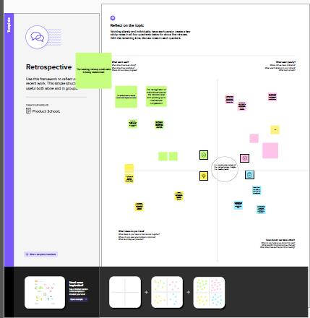

Brainstorm

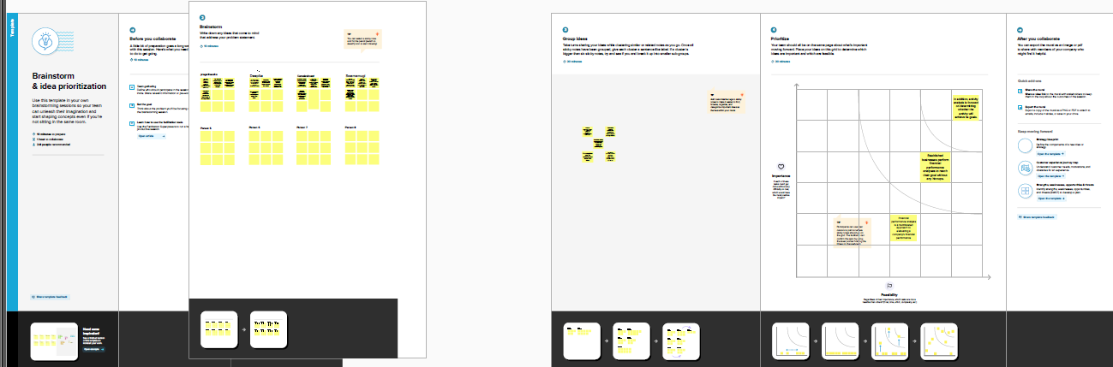

RESULT

Social impact:

Banking provides loans-impact financing and micro-credits with the goal of activity supporting social organizations and initiatives with measurable positive social impact.

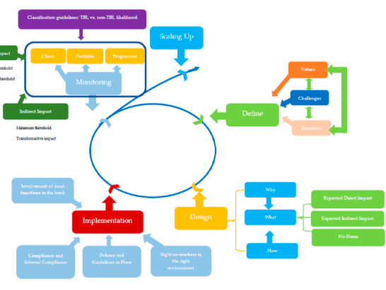

ADVANTAGES

* It helps identify frauds quickly and effortlessly.
* The efficiency of processing financial transactions is enhanced and well run.

DISADVANTAGES

* In some cases,larger financial institutions ay offer less competitive rates on loans and change larger fees than community banks or small credit unions.
* There are downsiders to big banks.

APPLICATION

* Fraud dedection
* Risk modelling for investment banks
* Credit risk analysis
* Sales performance analysis

CONCLUSION

A financial performance report is a summary of the financial performance of a company that reports the financial health of a company helping various investors and stakeholders take their investment decision.

FUTURE SCOPE

The future scope of banking is expected to be shaped by technology advancement, changes in regulatory environments and evolving customer needs.

APPENDIX

Source code-Dashboard

<div class='tableauPlaceholder' id='viz1682231012789' style='position: relative'><noscript><a href='#'><img alt='Financial Analysis of banks ' src='https:&#47;&#47;public.tableau.com&#47;static&#47;images&#47;PS&#47;PSProjectEntireProject1&#47;Dashboard1&#47;1_rss.png' style='border: none' /></a></noscript><object class='tableauViz' style='display:none;'><param name='host_url' value='https%3A%2F%2Fpublic.tableau.com%2F' /> <param name='embed_code_version' value='3' /> <param name='site_root' value='' /><param name='name' value='PSProjectEntireProject1&#47;Dashboard1' /><param name='tabs' value='no' /><param name='toolbar' value='yes' /><param name='static_image' value='https:&#47;&#47;public.tableau.com&#47;static&#47;images&#47;PS&#47;PSProjectEntireProject1&#47;Dashboard1&#47;1.png' /> <param name='animate_transition' value='yes' /><param name='display_static_image' value='yes' /><param name='display_spinner' value='yes' /><param name='display_overlay' value='yes' /><param name='display_count' value='yes' /><param name='language' value='en-US' /><param name='filter' value='publish=yes' /></object></div> <script type='text/javascript'> var divElement = document.getElementById('viz1682231012789'); var vizElement = divElement.getElementsByTagName('object')[0]; if ( divElement.offsetWidth > 800 ) { vizElement.style.width='100%';vizElement.style.height=(divElement.offsetWidth*0.75)+'px';} else if ( divElement.offsetWidth > 500 ) { vizElement.style.width='100%';vizElement.style.height=(divElement.offsetWidth*0.75)+'px';} else { vizElement.style.width='100%';vizElement.style.height='1527px';} var scriptElement = document.createElement('script'); scriptElement.src = 'https://public.tableau.com/javascripts/api/viz_v1.js'; vizElement.parentNode.insertBefore(scriptElement, vizElement); </script>

Source code – story

<div class='tableauPlaceholder' id='viz1682231135603' style='position: relative'><noscript><a href='#'><img alt='Story board ' src='https:&#47;&#47;public.tableau.com&#47;static&#47;images&#47;PS&#47;PSProjectEntireProject1&#47;Story1&#47;1_rss.png' style='border: none' /></a></noscript><object class='tableauViz' style='display:none;'><param name='host_url' value='https%3A%2F%2Fpublic.tableau.com%2F' /> <param name='embed_code_version' value='3' /> <param name='site_root' value='' /><param name='name' value='PSProjectEntireProject1&#47;Story1' /><param name='tabs' value='no' /><param name='toolbar' value='yes' /><param name='static_image' value='https:&#47;&#47;public.tableau.com&#47;static&#47;images&#47;PS&#47;PSProjectEntireProject1&#47;Story1&#47;1.png' /> <param name='animate_transition' value='yes' /><param name='display_static_image' value='yes' /><param name='display_spinner' value='yes' /><param name='display_overlay' value='yes' /><param name='display_count' value='yes' /><param name='language' value='en-US' /><param name='filter' value='publish=yes' /></object></div> <script type='text/javascript'> var divElement = document.getElementById('viz1682231135603'); var vizElement = divElement.getElementsByTagName('object')[0]; vizElement.style.width='100%';vizElement.style.height=(divElement.offsetWidth*0.75)+'px'; var scriptElement = document.createElement('script'); scriptElement.src = 'https://public.tableau.com/javascripts/api/viz_v1.js'; vizElement.parentNode.insertBefore(scriptElement, vizElement); </script>